**Power BI Hands on assessment:**

1. **Data Loading**

**Creating SQL Server and tables**

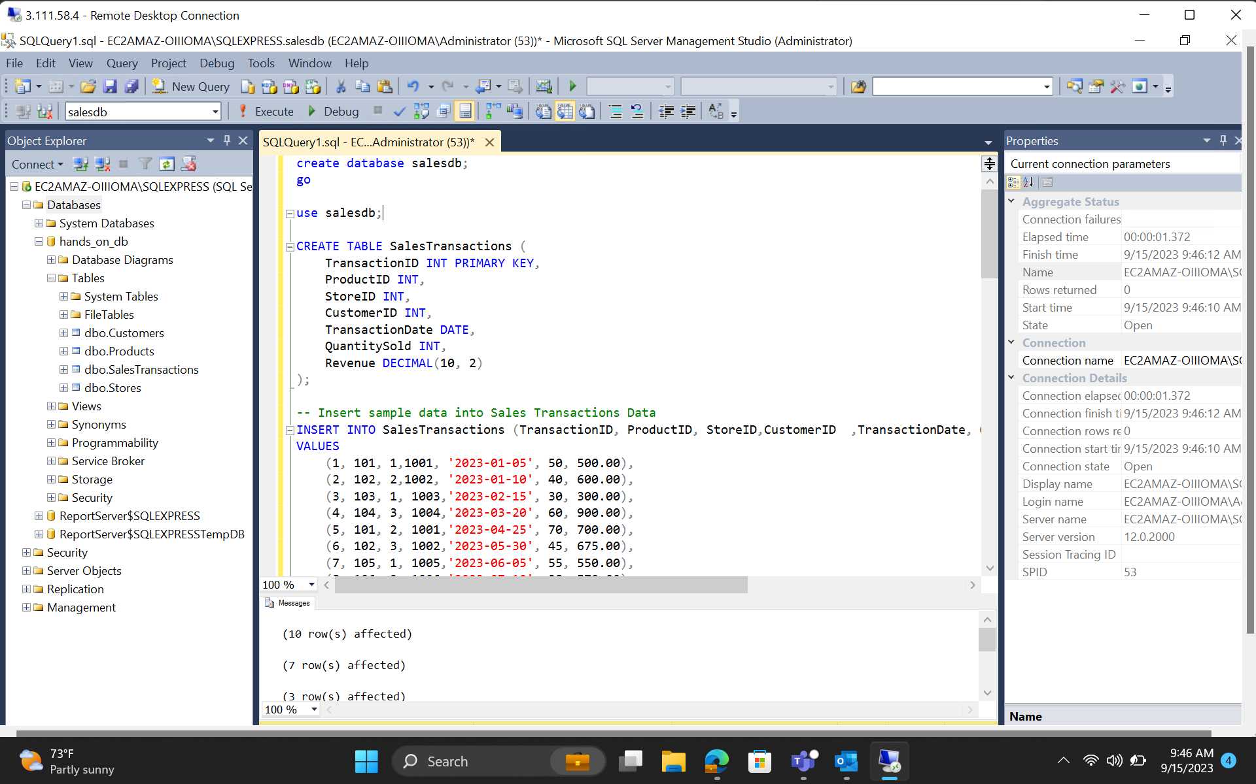

**Loading DB and Tables into Power BI**

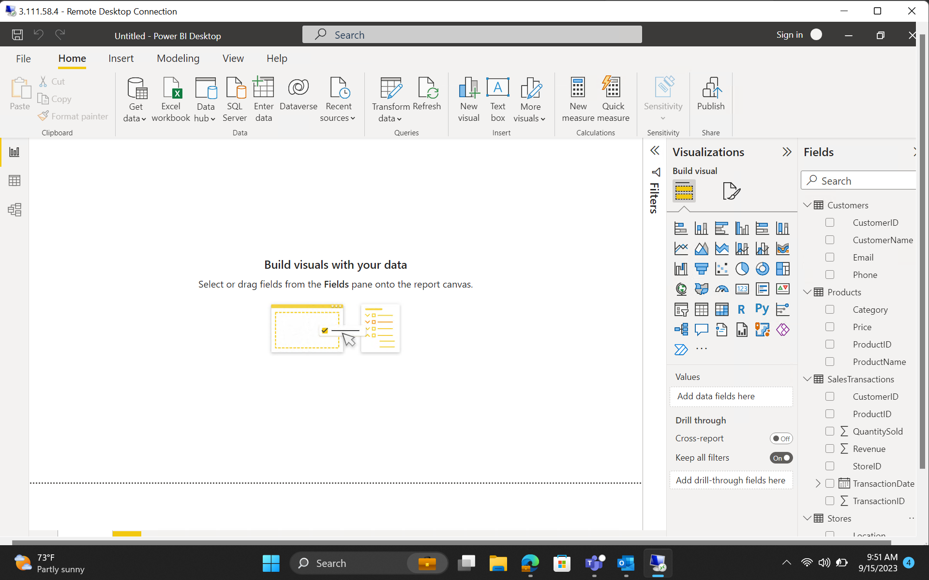

1. **Data Transformation**

**Merge Tables 🡪** Merging the SalesTransactions table to the respective Customer with the help of CustomerID.

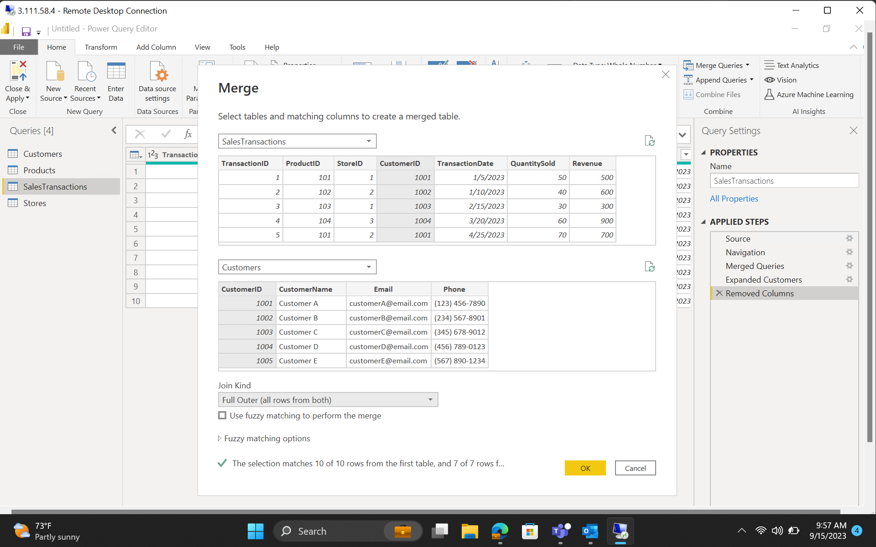

**Clean Data 🡪** Removing Duplicates from the newly created table.

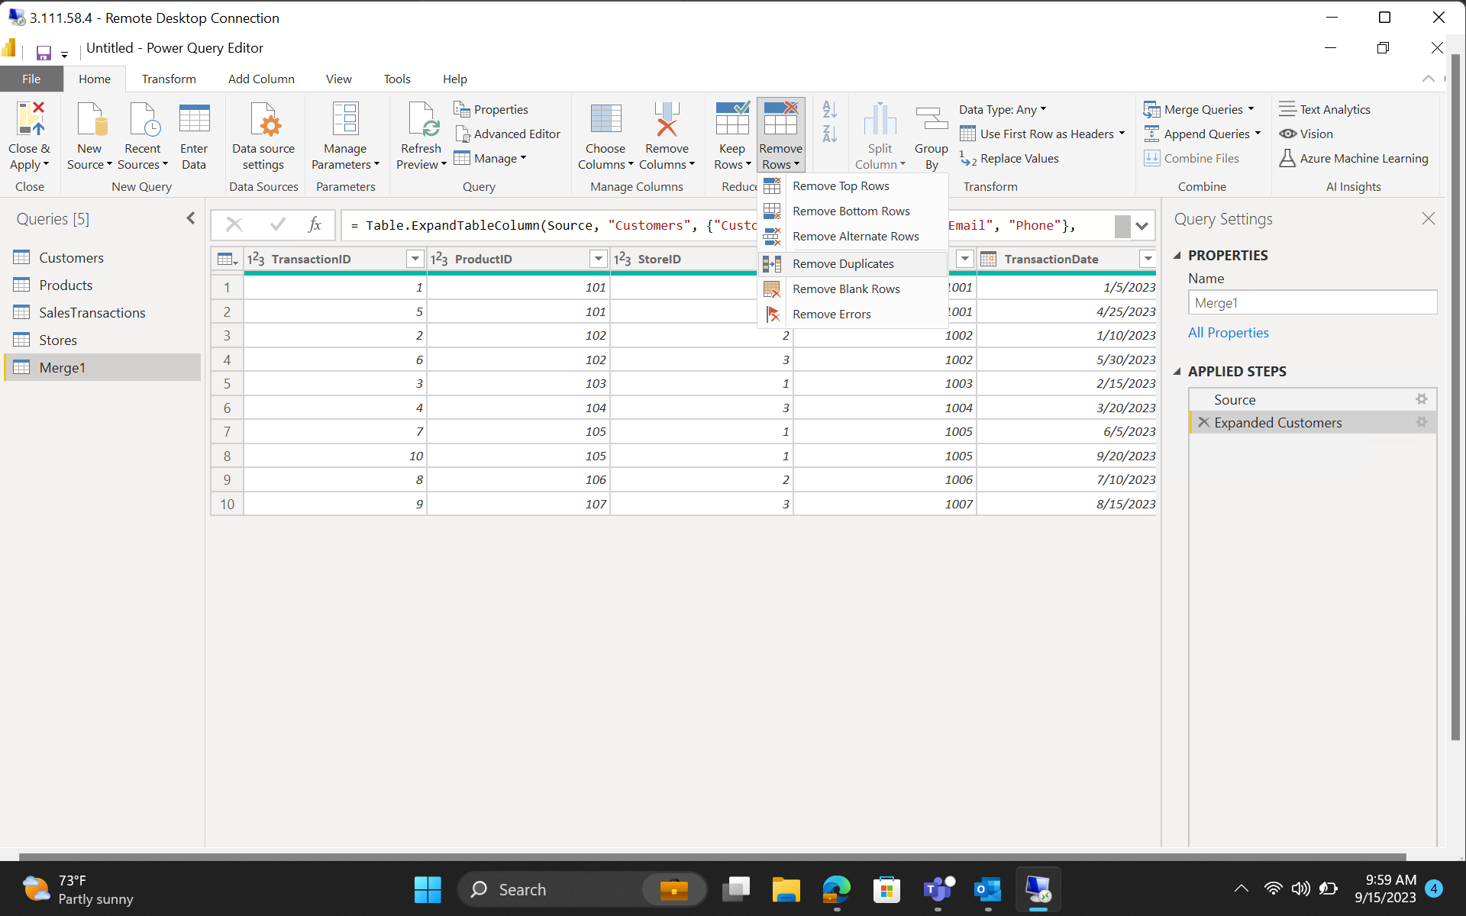

**Create Calculated Column 🡪** Added a new column RevenuePerUnit which tells the revenue gained from selling one unit of a product.

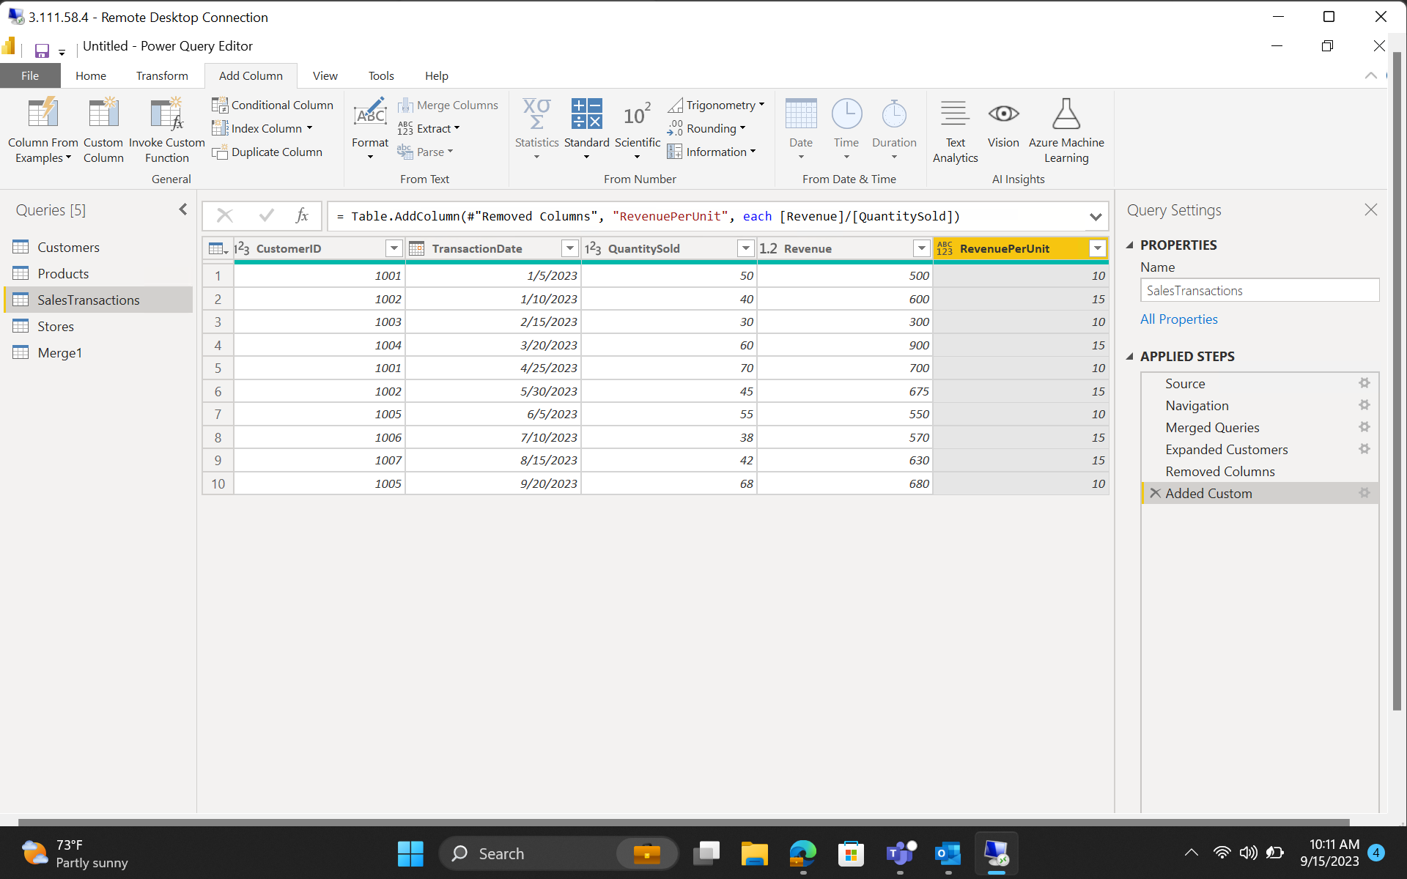

**Filter 🡪** Filtered the table such that ProductID and RevenuePerUnit of only those products will appear whose RevenuePerUnit is not 10.

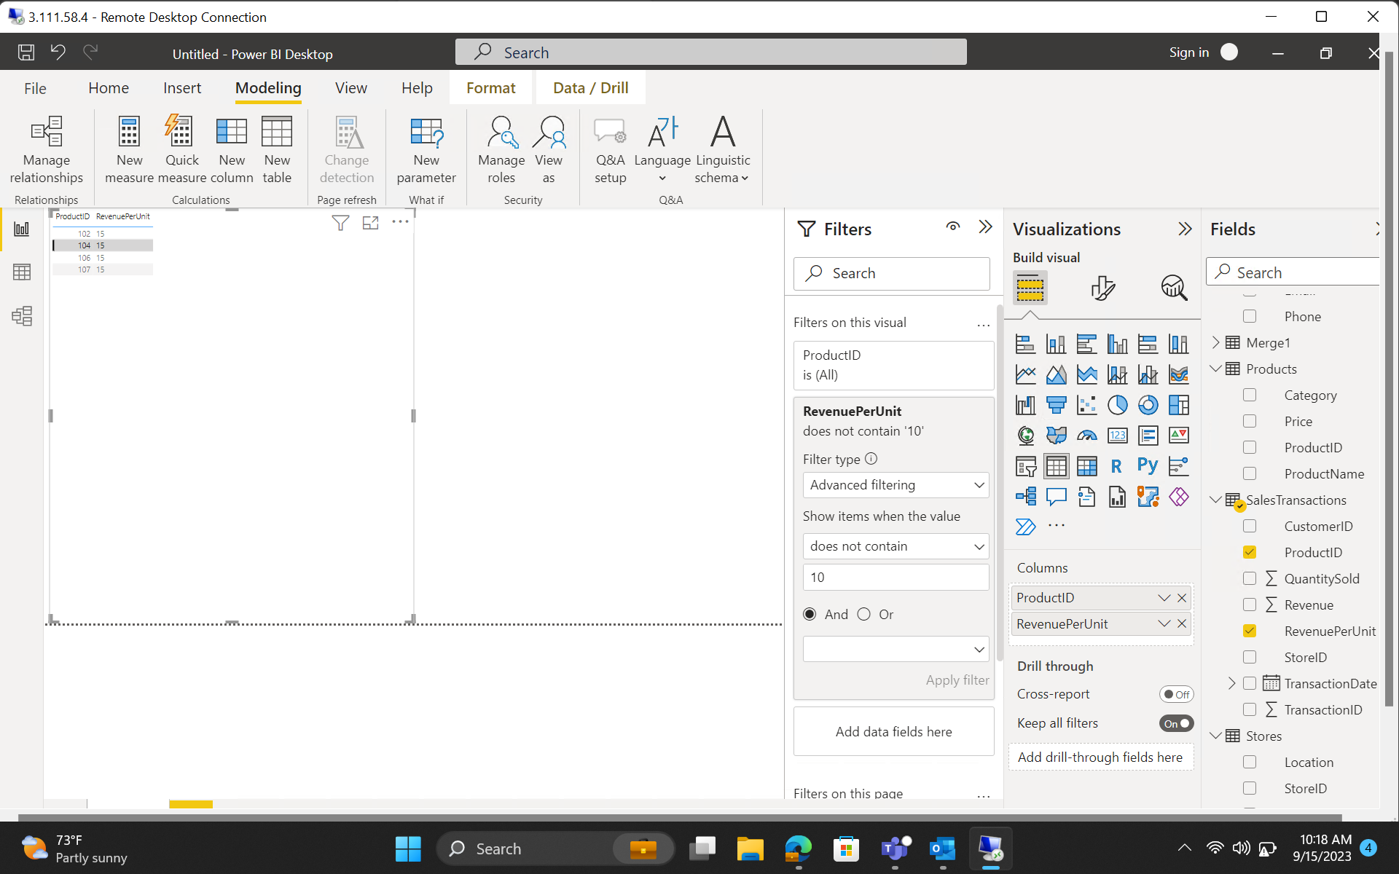

1. **Data Modelling**

**Create Relationship**

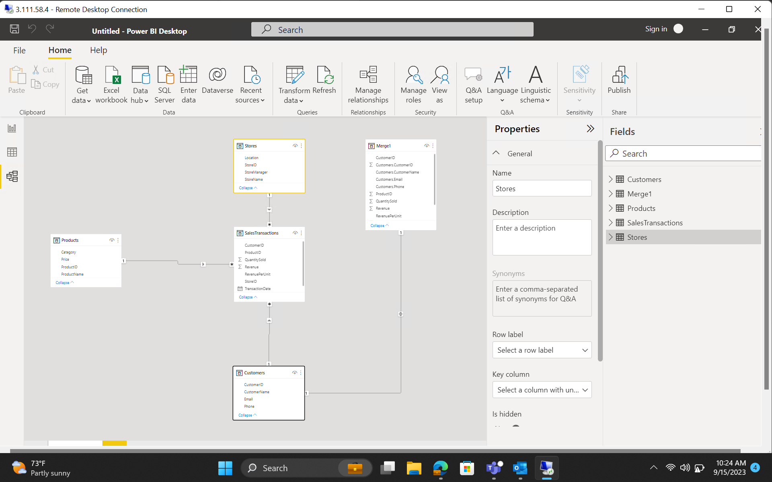

1. **Business Queries and Analysis**

**Customer vs Revenue Generated**

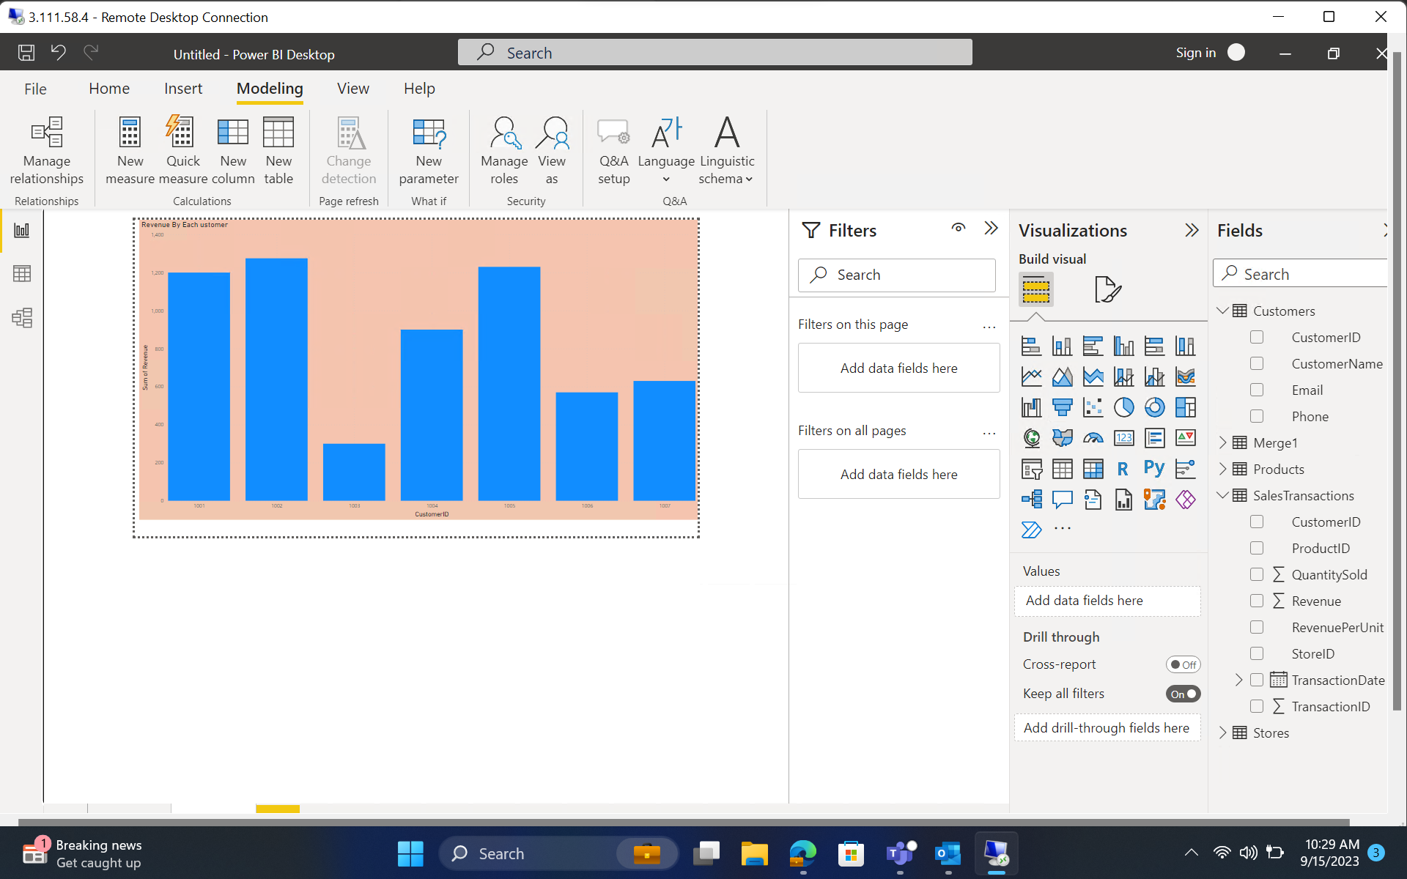

**Revenue Generated by each Store Manager**

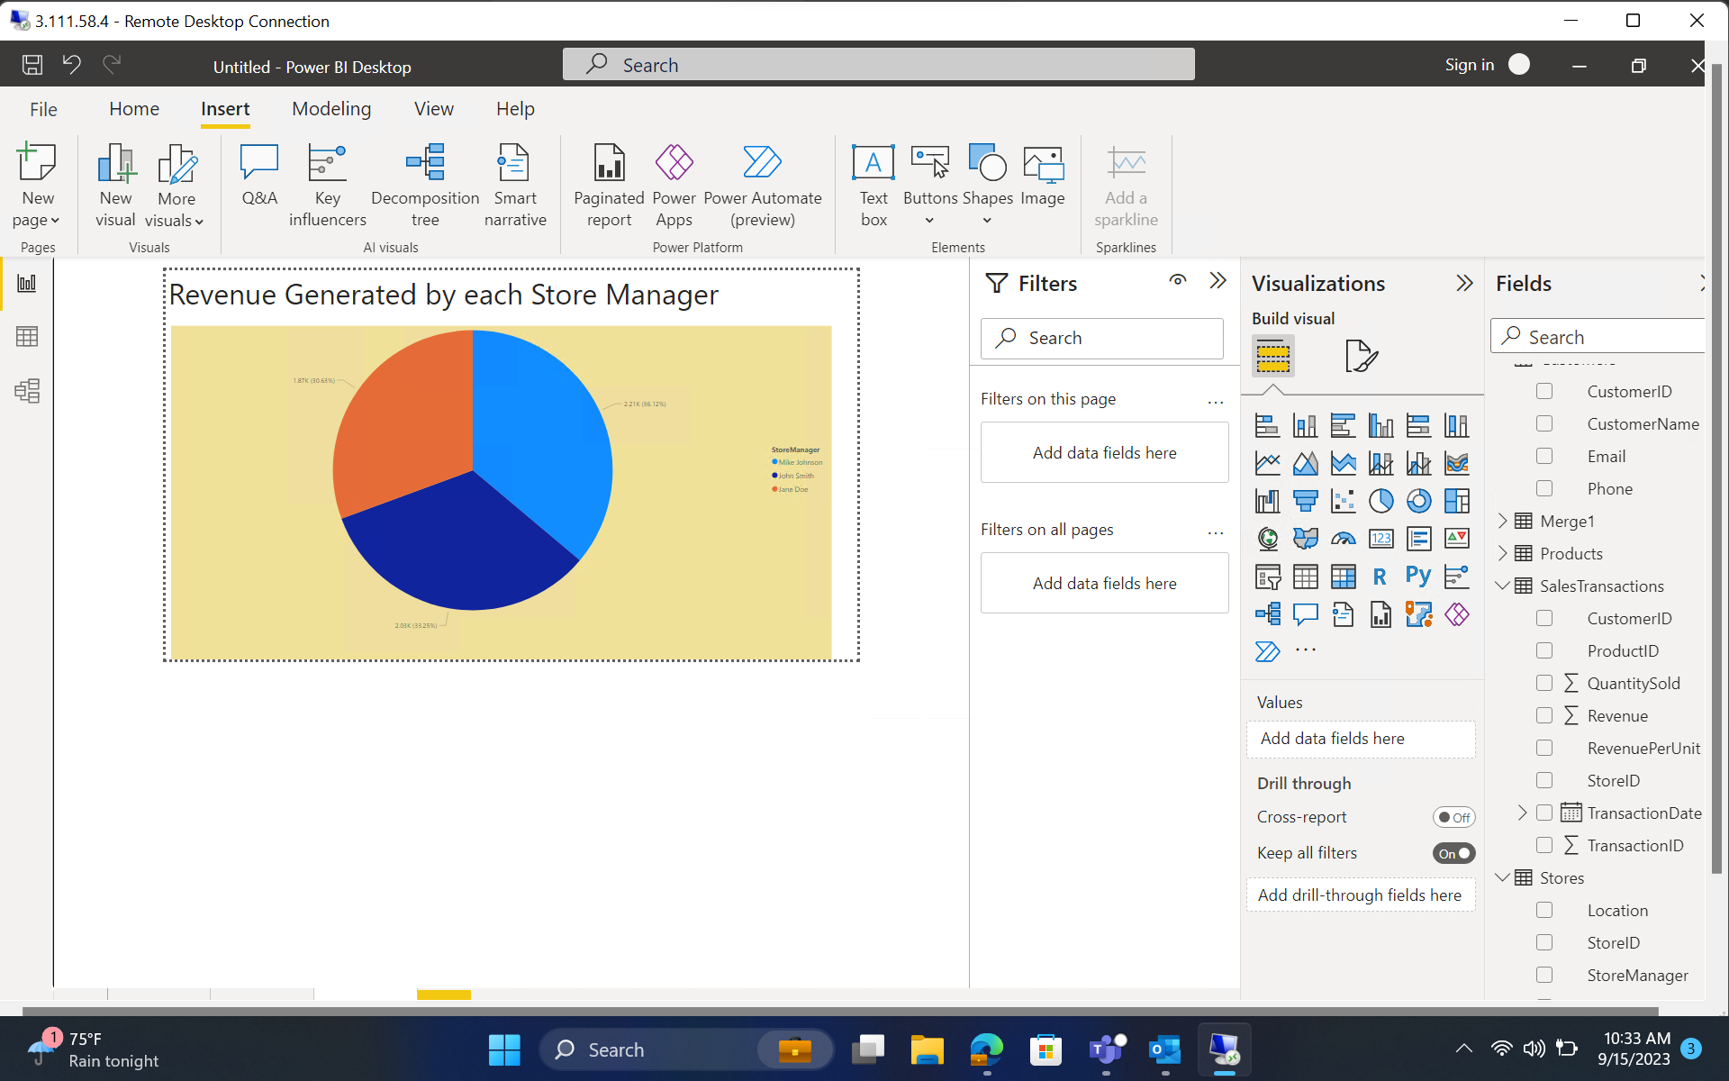

**Average Price based on Category**

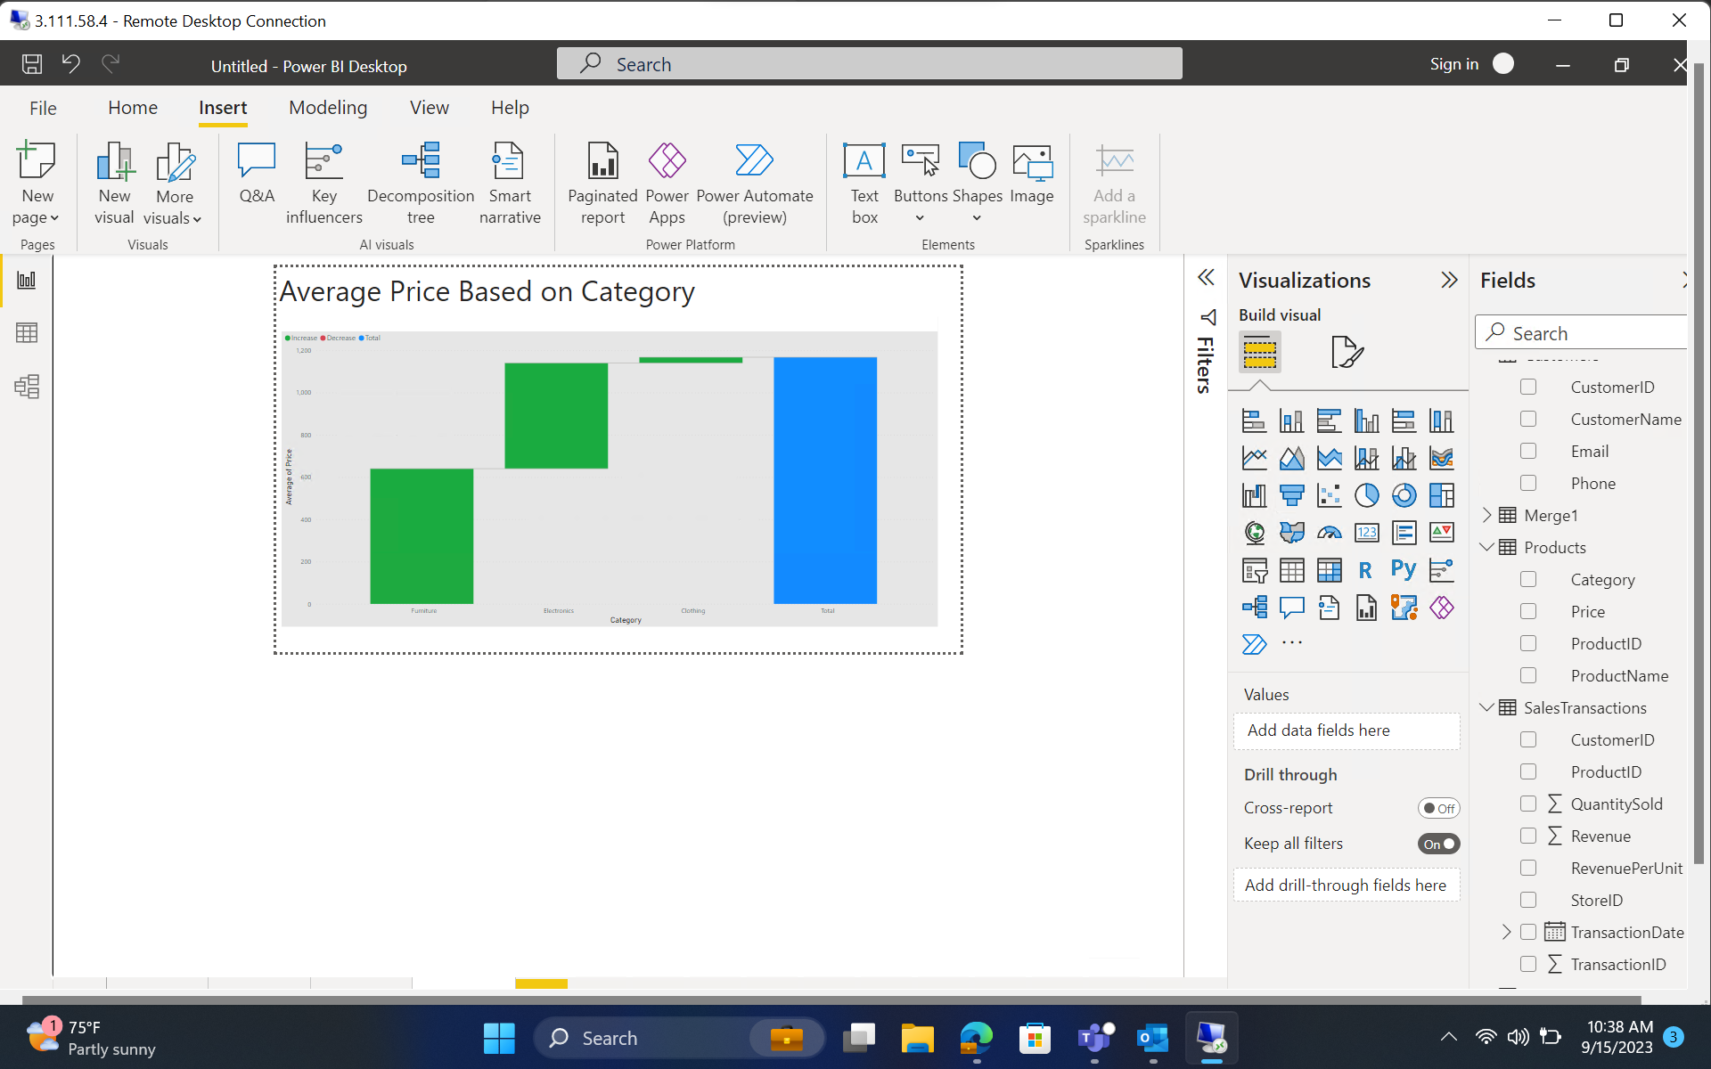

**Sales based on Month and Category**

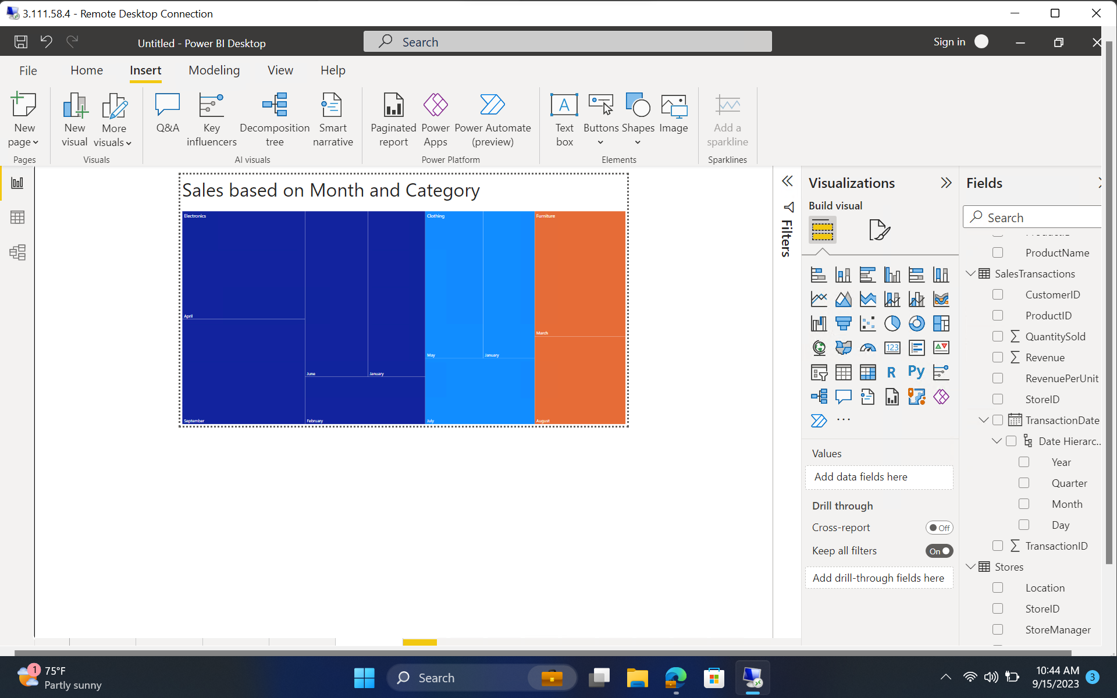

**Products consisting of 80% of Total Revenue**

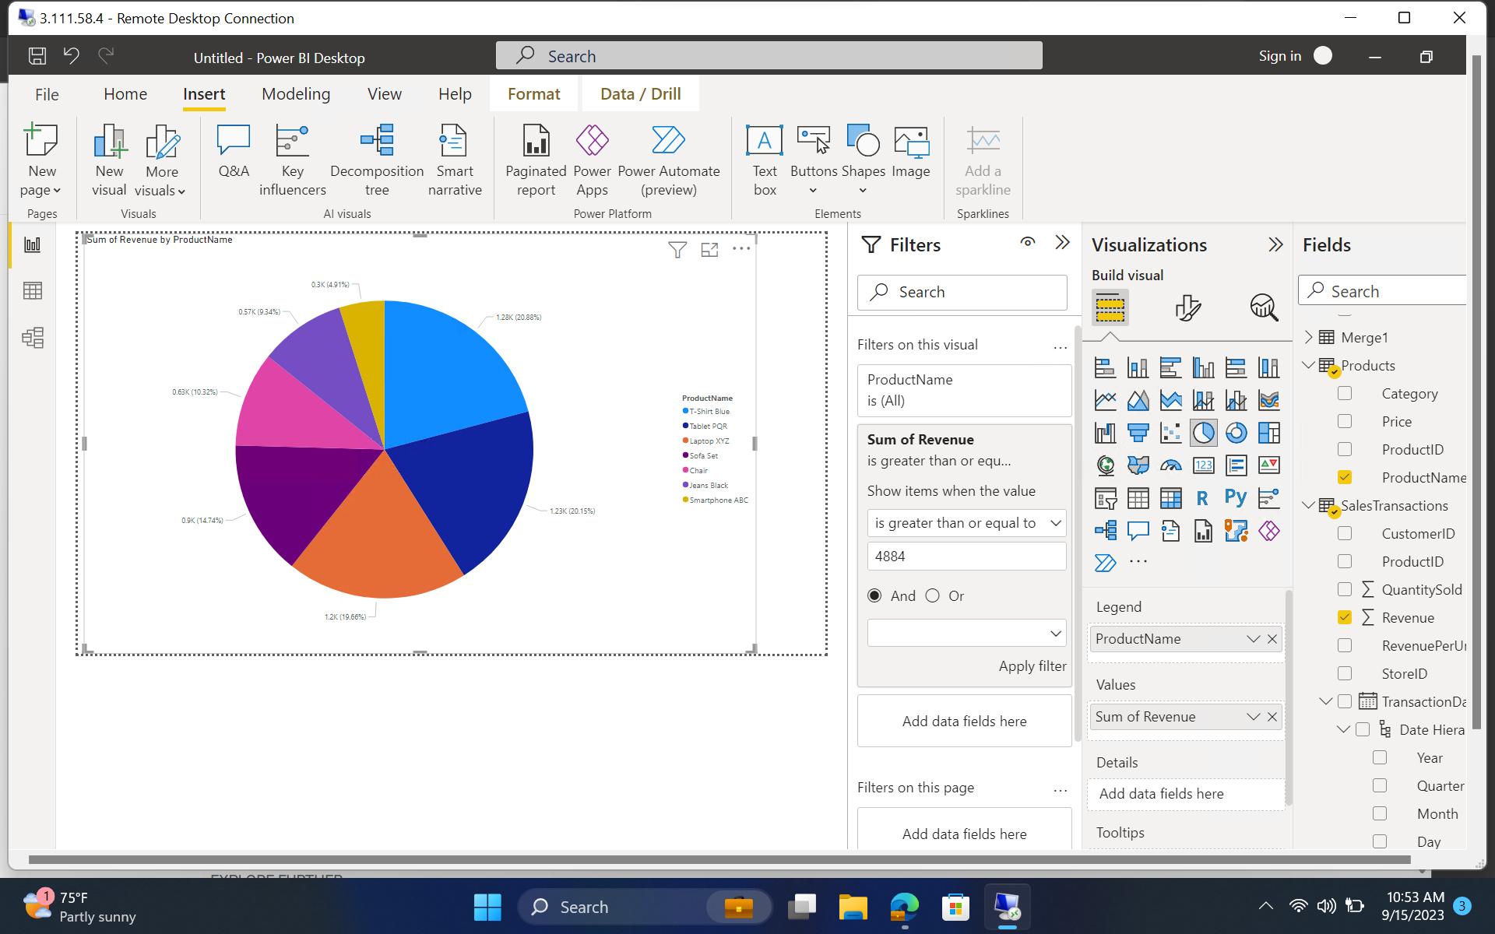

**Trend based on Customer and Category**

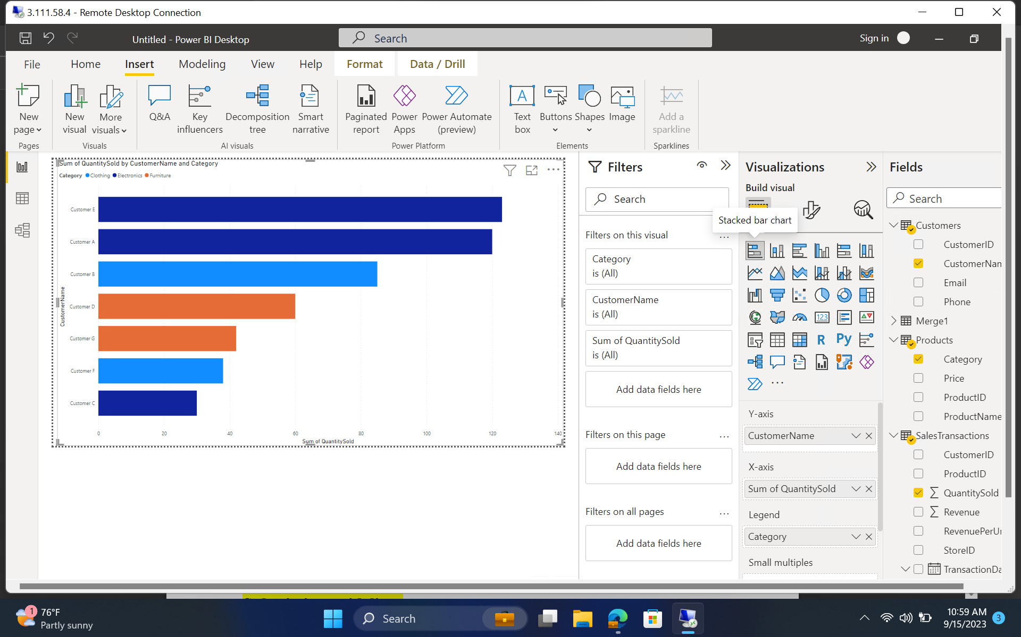

**Category doing best based on location**

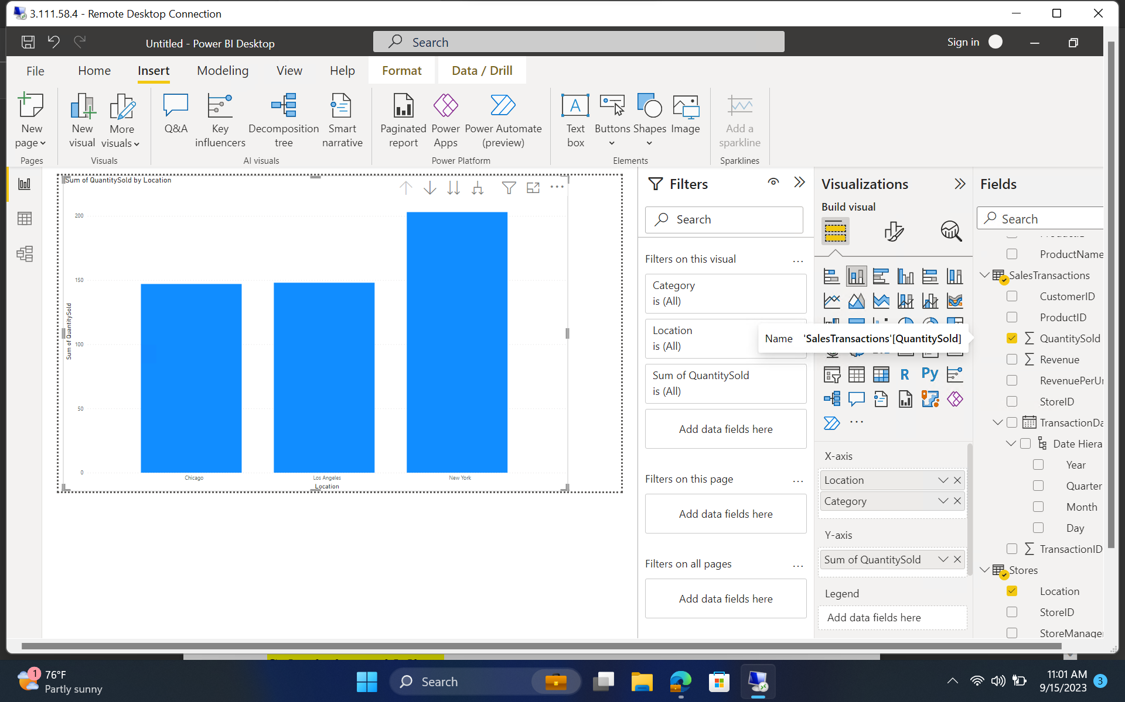

**Sales pattern based on seasons**

